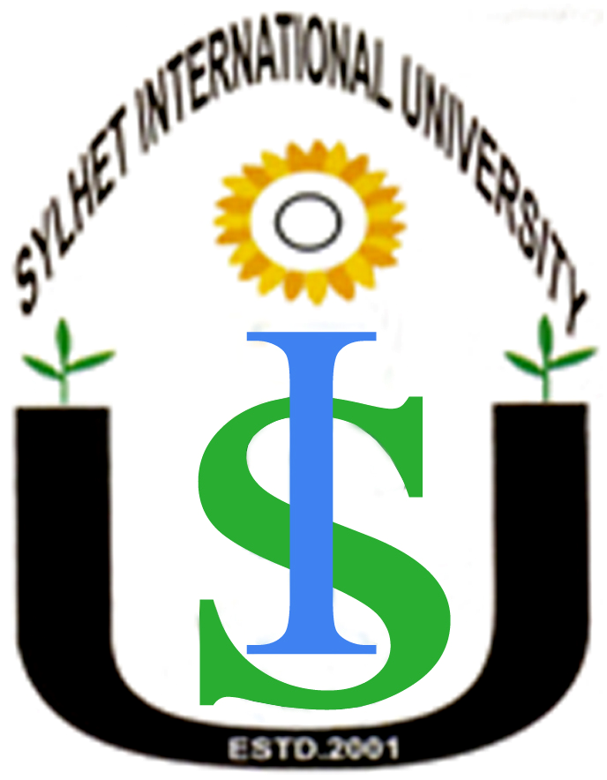
Sylhet International University

Name |  | Designation
1 | 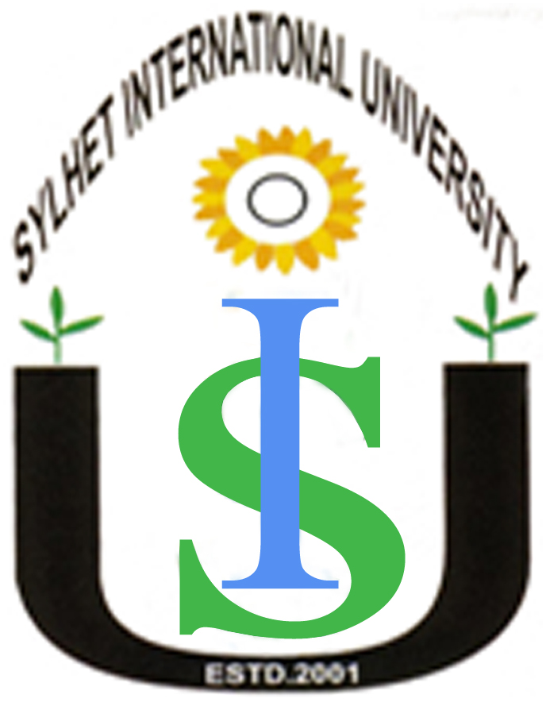  Prof. Dr.Susanta Kumar Das | Vice- Chancellor
2 | Prof. Syed Muyeejur Rahman | Professor &  Dean , School of Humanities
3 | Prof. Dr. Khandoker Md. Mominul Haque | Professor &  Head , CSE
4 | Prof. Muhammad Ruhul Amin | Professor
5 | Mr. A. F. M. Aminul Islam | Exam- Controller
6 | Mr. Md. Abdul Latif | Associate Professor & Head, BA
7 | Mr. Ekramul Farook, | Associate Professor  & Head, ECE
8 | Mr. Jowhar Lal Das | Assistant Professor &  Head , Law
9 | Mr. Prodhan Mahbub Ibna Seraj | Assistant Professor  & Head, English
10 | Ms. Nasrat Afza Chowdhury | Registrar
11 | Mr. Sushanta Acharjee | Finance Director
12 | Mr. Md. Tareq Uddin Taj | Public Relation Officer, BOT, SIU

